Main page

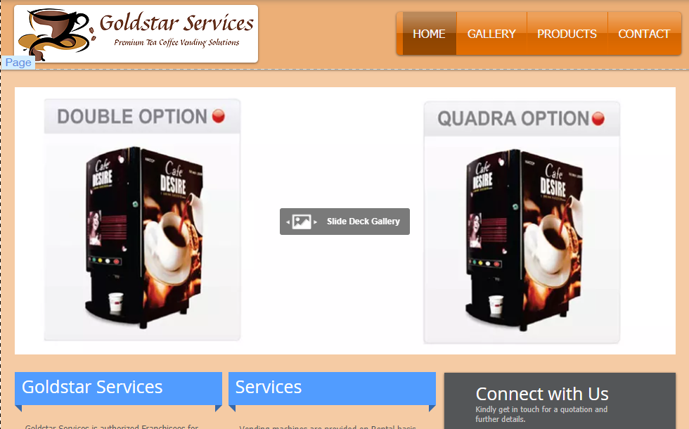

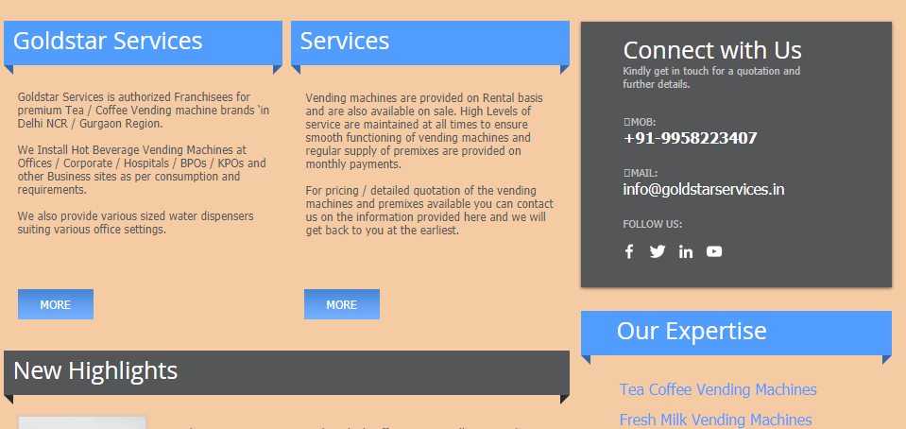

Goldstar Services is authorized Franchisees for premium Tea / Coffee Vending machine brands ‘in Delhi NCR / Gurgaon Region.

​

We Install Hot Beverage Vending Machines at Offices / Corporate / Hospitals / BPOs / KPOs and other Business sites as per consumption and requirements.

​

We also provide various sized water dispensers suiting various office settings.

Vending machines are provided on Rental basis and are also available on sale. High Levels of service are maintained at all times to ensure smooth functioning of vending machines and regular supply of premixes are provided on monthly payments.

​

For pricing / detailed quotation of the vending machines and premixes available you can contact us on the information provided here and we will get back to you at the earliest.

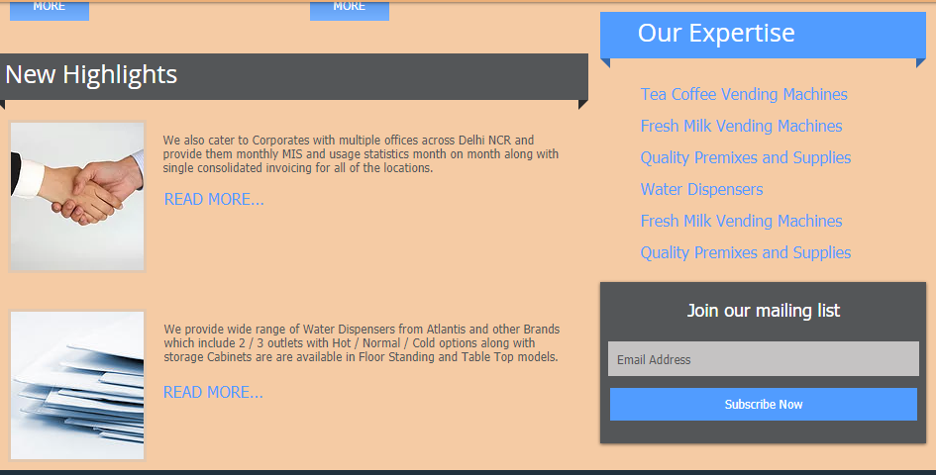

We also cater to Corporates with multiple offices across Delhi NCR and provide them monthly MIS and usage statistics month on month along with single consolidated invoicing for all of the locations.

We provide wide range of Water Dispensers from Atlantis and other Brands which include 2 / 3 outlets with Hot / Normal / Cold options along with storage Cabinets are are available in Floor Standing and Table Top models.

Our Expertise

Tea Coffee Vending Machines

Fresh Milk Vending Machines

Quality Premixes and Supplies

Water Dispensers

Fresh Milk Vending Machines

Quality Premixes and Supplies

Connect with Us

Kindly get in touch for a quotation and further details.

​

MOB:

+91-9958223407

MAIL:

info@goldstarservices.in

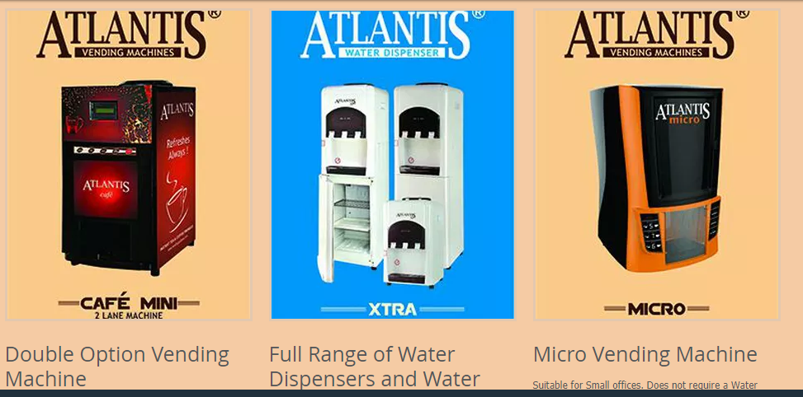

Double Option Vending Machine

Suited for medium staffed Offices; Sturdy and Robust machines requiring minimum maintenance and provides years of trouble free service.

##### Full Range of Water Dispensers and Water Coolers

2 Taps / 3 Taps / Floor Standing / Desktop / With Normal Cabinets / With Cooling Cabinets. We have complete and affordable range of water dispensers required for all office sizes.

##### Micro Vending Machine

Suitable for Small offices. Does not require a Water Bottle to be placed on top. Has in built water storage and is fully customizable to dispense beverages. Perfect fit for small offices. Affordable and great quality product from leading manufacturers.

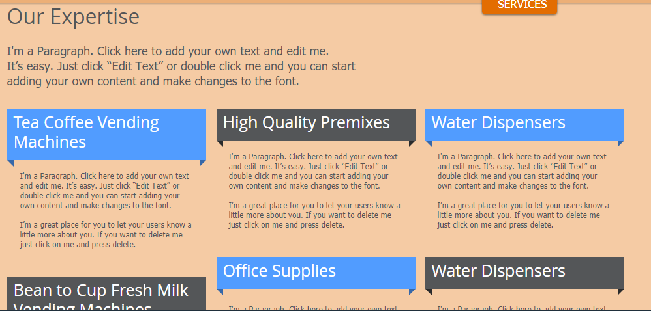

Our Expertise

I'm a Paragraph. Click here to add your own text and edit me.

It’s easy. Just click “Edit Text” or double click me and you can start

adding your own content and make changes to the font.

Tea Coffee Vending Machines

High Quality Premixes

Water Dispensers

Bean to Cup Fresh Milk Vending Machines

Office Supplies

Water Dispensers

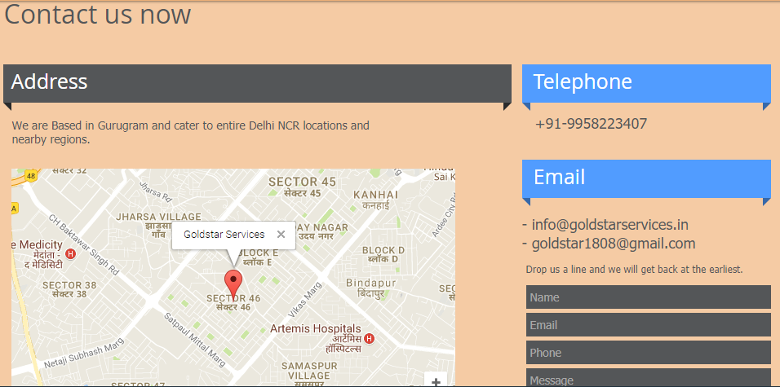

Address

We are Based in Gurugram and cater to entire Delhi NCR locations and nearby regions.

Telephone

+91-9958223407

Email

- info@goldstarservices.in

- goldstar1808@gmail.com

Drop us a line and we will get back at the earliest.